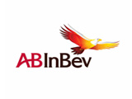  ABInBev  AB InBev partners with AIESEC through the Global Exchange Program, supporting over 25 interns every year and providing in-kind support at global conferences. | 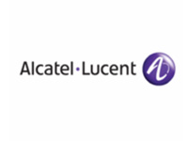  Alcatel Lucent  A partner since 2004, Alcatel-Lucent realises more than 40 internships a year and is focused on sourcing technology & management talent for projects in Europe, Middle East, Africa, Asia and Americas. | 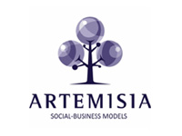  Artemisia  Combining Artemisia's expertise with AIESEC's global network, we have successfully co-created the Social Business Ventures Program, allowing AIESEC members to deepen their understanding of Social Business.
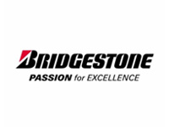  Bridgestone  AIESEC International has been a source for the Bridgestone European Graduates Program for the past year. | 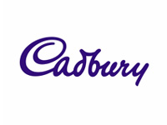  Cadbury  Cadbury has been a partner over six years and is supporting AIESEC by developing leadership in our members. | 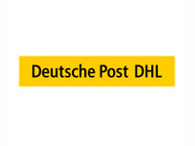  Deutsche Post DHL  AIESEC's relationship with Deutsche Post DHL is one of the largest global partnerships, realising over 100 interns every year across the world and supporting the recognition of AIESEC Alumni.
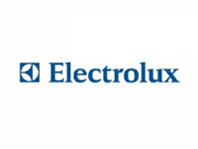  Electrolux  For over 5 years now, Electrolux has been a strong global partner of AIESEC, every year giving opportunities to over 35 young professionals from AIESEC in 3 continents | 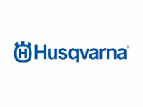  Husqvarna  Husqvarna joined the AIESEC Global Exchange Program in January 2009 becoming the newest global partner of AIESEC International | 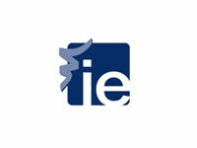  IE  IE is seeking to attract the best young talent for its Master programs and believes AIESEC members are outstanding candidates.
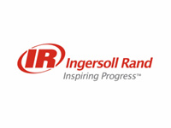  Ingersoll Rand  Ingersoll Rand sources their Early Development Program with high talented AIESEC graduates every year. | 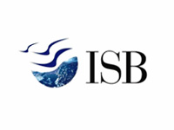  ISB  AIESEC members are taleneted youth coming from diverse backgrounds, who demonstrate natural leadership abilities which ISB seeks in line with their organisational vision to groom future leaders for the world. |   Microsoft  A Global Partner since 2006, Microsoft has realised more than 60 internships. AIESEC and Microsoft also co-operate around the MSDNA Academic Alliance, Students To Business program and Alumni intiatives.
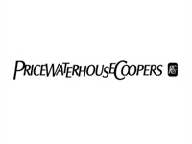  PwC  PwC has been supporting AIESEC globally now for over 3 decades. The partnership includes co-operation in the global exchange program, alumni initiatives, advisory support. | 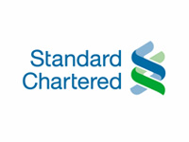  Standard Chartered  Standard Chartered Bank sponsor AIESEC projects under the HIV Learnng Network to educate 30,000 young people on HIV and AIDS by 2010 across the Asia Pacific and Africa region. | 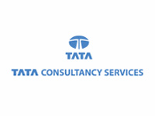  TCS  Alongside attracting talent for their Asian technology projects,TCS supports AIESEC in maintaining MyAIESEC.net, the global internal platform which connects 40 000+ members and 50 000+ Alumni worldwide.
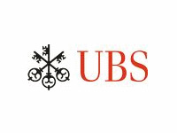  UBS  Taking 40 Interns every year and supporting other key initiatives, UBS was the first AIESEC Global Partner and has been in partnership with AIESEC for more than 40 years | 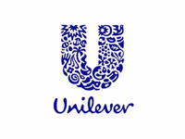  Unilever  The Global partnership between Unilever and AIESEC is focused on talent management and brand advisory. | 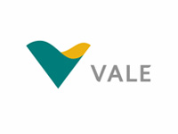  Vale  Vale partners with AIESEC to source high potential international top talent for the Global Trainee Program.

Our Supporters

- European Commission, Executive Agency Education, Audiovisual and Culture
- Ashoka
- Career Innovation
- IUCN- International Union for Conservation of Nature
- EABIS: European Academy of Business in Society
- EAIE: The European Association for International Education
- EBBF: The European Bahá'í Business Forum
- EBS: European Business Summit
- EFMD: European Foundation for Management Development
- Future Considerations
- United Nations Global Compact
- GRI: Global Reporting Initiative
- Instyle
- JCI: Junior Chamber International
- JA: Junior Achievement
- Pioneers of Change
- SoL: Society for Organizational Learning
- Taking IT Global
- Tallberg Foundation
- Transparency International
- World Economic Forum
- WWF: World Wildlife Fund
- UNESCO
- The World Bank
- UN Habitat

